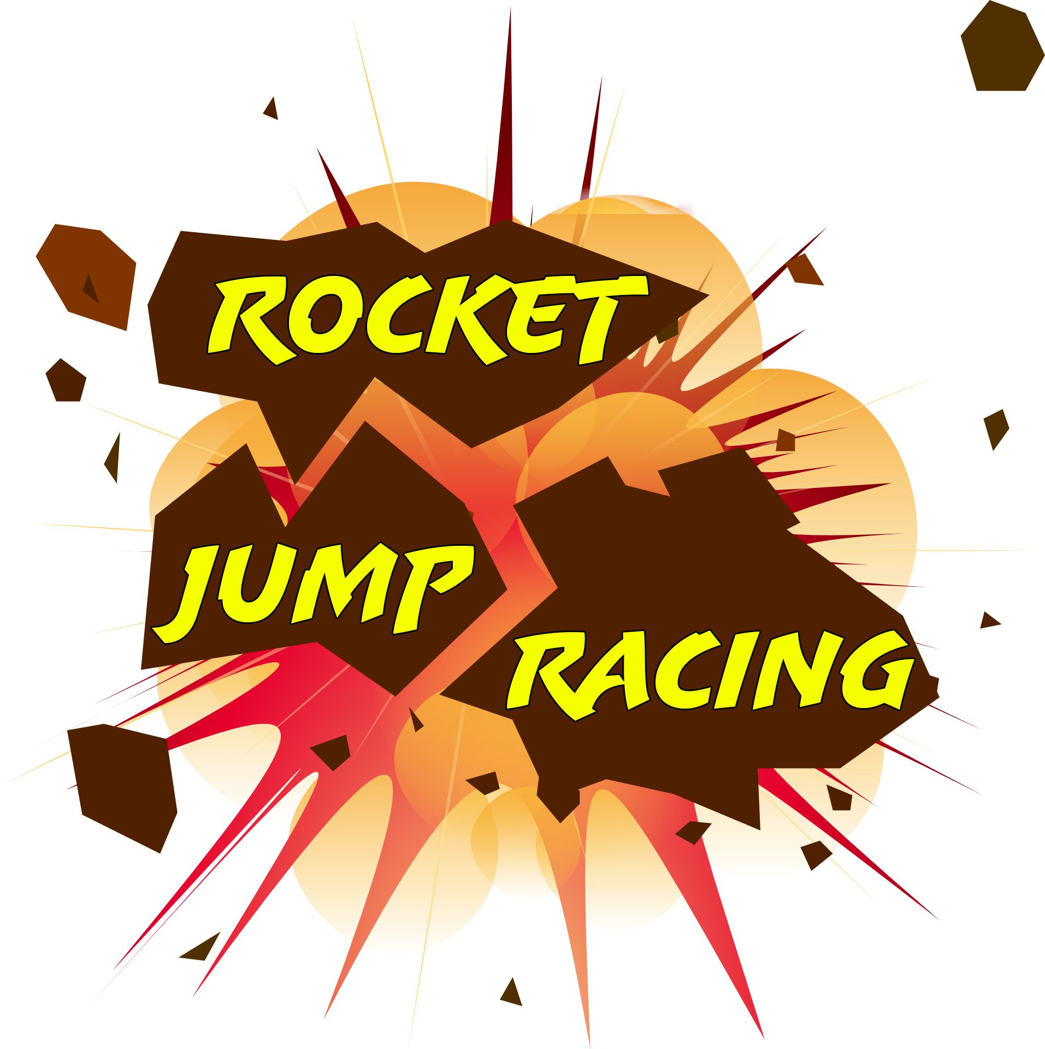

Arena 1

Designer:

Documentation Creation Date: 12/3/20

Level Finish Date:

Version:

Last Update Date:

**Table of Contents**

**Level Layouts**

**Layout Elements Key**

**Gameplay**

**Game Narrative (Leading up to this Level)**

**Level Objectives**

**Level Narrative & Walkthrough**

**Mechanics Required to Complete Level**

**Previous to this Level**

**Learned in this level**

**Special Features**

**Look and Feel**

**General**

**Genre**

**Mood**

**Pacing**

**Environment** *(Each Unique Section requires the following)*

**Architecture**

**Materials**

**Color Composition**

**Lighting**

**Initial Visual Impacts**

**Music \ Sound \ Dialogue**

**Level Music**

**Sound and Music Inspirations**

**Ambient Sounds**

**Specific Sounds**

**Dialogue \ Voice Over**

**Asset Lists**

**Packages \ Sets**

**Unique Level Elements**

**Other Level elements**

**List of Elements Needed**

**Level Layouts**

The arena itself has a large dome in the center that the players span under. In the center of that dome is a statue of some kind with a jump pad on top. If the player enters the jump pad in time with the song, that player will be shot into the air. The top of the dome has an opening for the players to rocket jump/fall through. Around the outside of the dome there will be floating platforms with power-ups for players to collect.

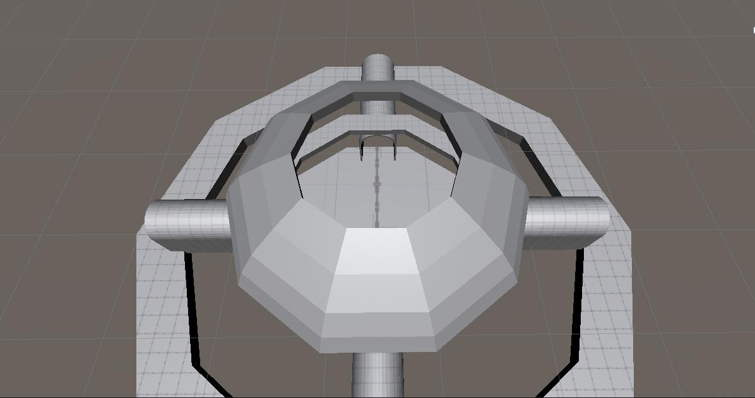

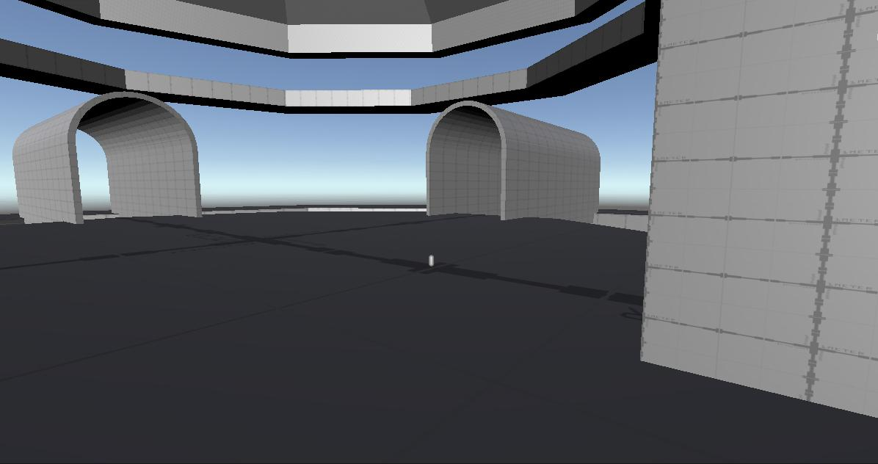

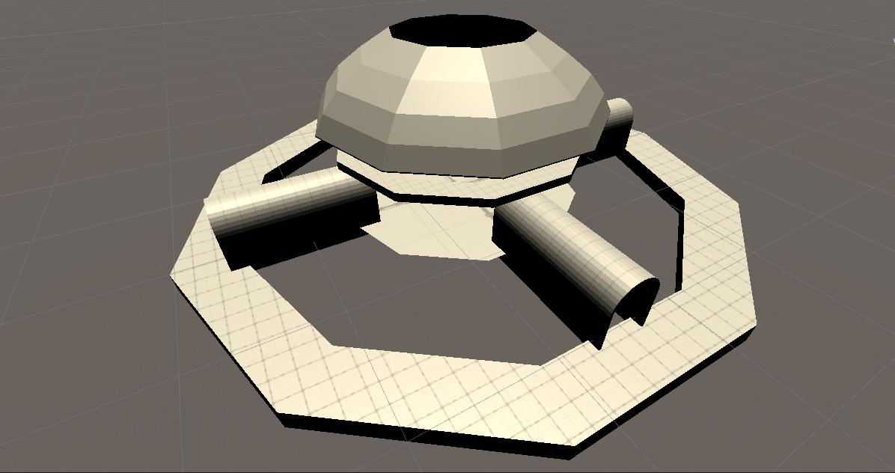

**Gameplay**

**Game Narrative:**

Hot-potato with an explosive pineapple.

**Level Objectives:**

Be the last man standing.

**Level Narrative:**

You are a racer for the RJR racing network. This time instead of racing the players are passing off an explosive pineapple to each other to be the last one standing.

**Level Mechanics:**

Jump pads to launch the players into the air and power-ups to reward those players for going to more-difficult areas of the map to reach, adding to the strategy of the game.

**Look and Feel**

**General:**

The general look for the game is going to be a retro future sort of aesthetic.

**Genre:**

The genre for the game is a space sci-fi genre.

**Mood:**

In terms of mood, we’re going for more of a teen style sort of humor, while still being a lighthearted game that kids could play.

**Pacing:**

For the pacing of the game, the faster the better. We want players to be able to move very quickly, while still maintaining a sense of control both in the air and on the ground. After all, our primary game modes are based around being fast to avoid other players/ outposition other players to win.

**Environment**

**Architecture:**

For the architecture of our game, we are working more with very geometric shapes to keep in line with our Retro-Future aesthetic. For this, we mostly use shapes like spheres and cylinders to create a more smooth sort of shape for our buildings within a level.

**Materials:**

In terms of materials, most things are going to be built out of metallic materials, plastic materials, and some glass materials.

**Color Palette:**

Our color palette is going to be more of a bright, cheery version of city style neon lights. We also will include some more moderate colors, like whites and greys to help offset the overall brightness of the neon coloring.

**Lighting:**

As far as lighting goes, we want to have some lights, such as indicators for direction to be very distinct lights, while still working in a bright environment.

**Initial Visual Impacts:**

The biggest visual impacts should be the directional lights, and the race track itself. After that it will be the players within the race track as the next big visual impact.

**Music\Sound\Dialogue**

**Level Music:**

For the level music, we will be implementing a small selection of songs that promote the Retro-Future aesthetic, while still providing a healthy beat to help in setting up the music interaction within the level.

**Inspirations:**

For music inspirations, we’ll be looking at Motor Mayhem again for it’s more industrial sound, as well as some songs by Caravan Palace, Parov Stelar, Gorillaz, and Meganeko.

**Ambient Sounds:**

There will be very little to no ambient sounds outside of maybe some cheering from a crowd and specific sounds for the jump pad and boost pad.

**Specific Sounds:**

For the sound design of the game, we will be implementing explosion sound effects for all characters, as well as footstep sound effects, impact sound effects, and various grunt noises to show the player being hit by something (such as a rocket) and/or landing/making an impact against something.

**Dialogue:**

We will most likely not be implementing dialogue for the game at this time.

**Assets**

* Boost Pad
* Power-ups
* Arena
* Obstacles
* Jump Pads